CS349 ASSIGNMENT 1 Rashi Singh
Learning Network Diagnostic Tools 170101052

Q1 : PING command :
a) To specify the number of echo requests : ping -c count <host_name>
b) To set time interval btw 2 successive pings : ping -i interval <host_name>
* min value of interval : 0.2 sec for non super-users
* default value of interval : 1 sec for all users
c) To send packets without waiting for reply : ping -l count <host_name>
* max value of count : 3 for non super-users
d) To specify packet size : ping -s size <host_name>
* Additional 8 bytes for ICMP header and 20 bytes for IP header
* For packet size = 32 bytes, total packet size = 32 + 28 = 60 bytes

Q2 : PING - RTT experiment :
* All readings were taken via http://www.spfld.com/ping.html (server location: New Jersey)
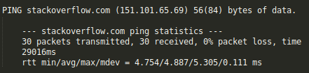
PACKET LOSS :
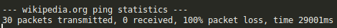
There was no case of packet loss greater than 0% for packet size 64 bytes. However, packet loses might occur due to network congestion. Sometimes, 100% packet loss is also witnessed, as hosts block ICMP packets (low-priority) to reduce traffic.

CORRELATION B/W RTT AND PACKET SIZE :
* From the chart below, the following observations can be made :
a) For smaller packet sizes (less than 2048 bytes), RTT is more or less a stable value.
b) For packet size of 2048, only 2 out of 6 hosts received any packets. Hence, only imdb, amazon map the RTT corresponding to 2048 byte packet size.
* These observations can be expained from the fact that MTU (Maximum Transmission Unit, i.e, the maximum number of octets that the network interface can handle) has a default value of 1500, Therefore, packets of size greater than 1500 are either rejected or broken into smaller packets resulting into a higher RTT.
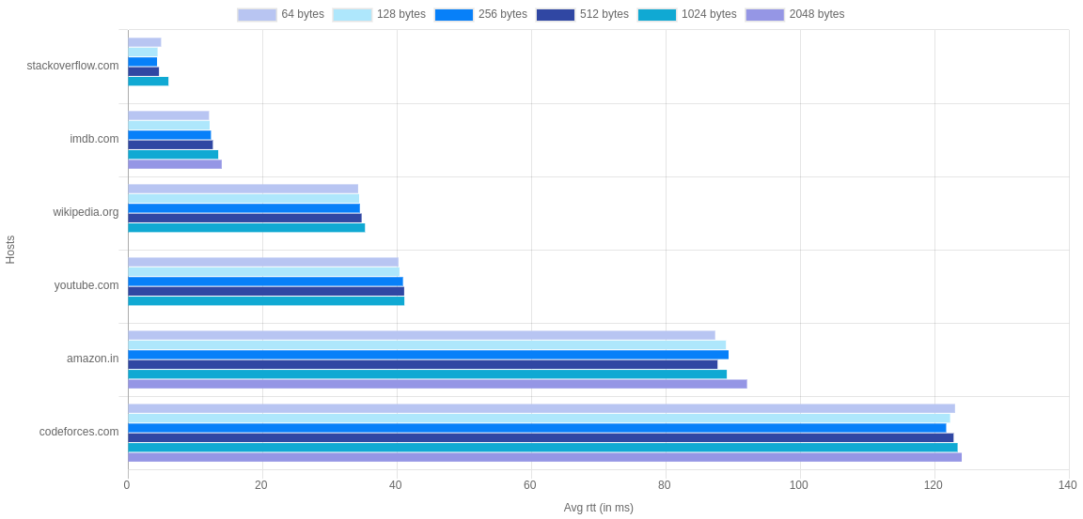Illustration 1 : CORRELATION BETWEEN RTT AND PACKET SIZE

STRONG CORRELATION B/W RTT AND GEOGRAPHICAL DISTANCE :
* The ROUND TRIP TIME (RTT) is shows “strong, positive linear relation” with distance bcs :
a) Increase in propagation delay – This occurs bcs of increased distance
b) Increase in processing and queuing delay – This occurs bcs of more no. of hops
* This can be seen in the table below. RTT increases with distance, especially in case of inter continental pings (Russia, Ireland from USA).
* DEVIATIONS : Significant deviations from linear relation arise due to large-scale routing behaviours, like the noise introduced by the procedure.
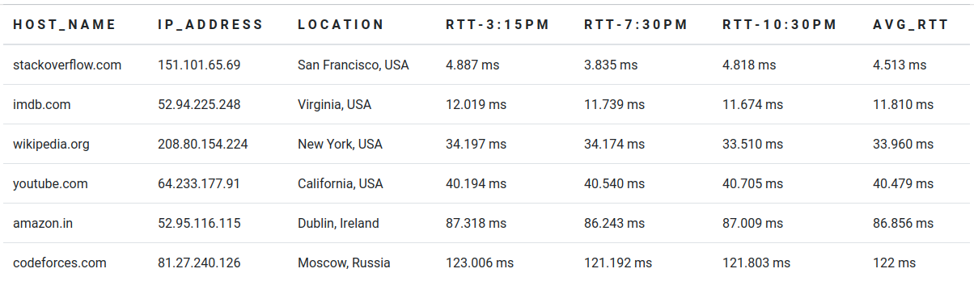
CORRELATION B/W RTT AND TIME OF THE DAY :
* From the data in the above table, it can be observed that RTT varies with time of the day. This is because higher congestion leads to more ROUND TRIP TIME. Hence it can said that the network traffic is less at 7:30 PM IST as compared to 3:15 PM and 10:30 PM IST.
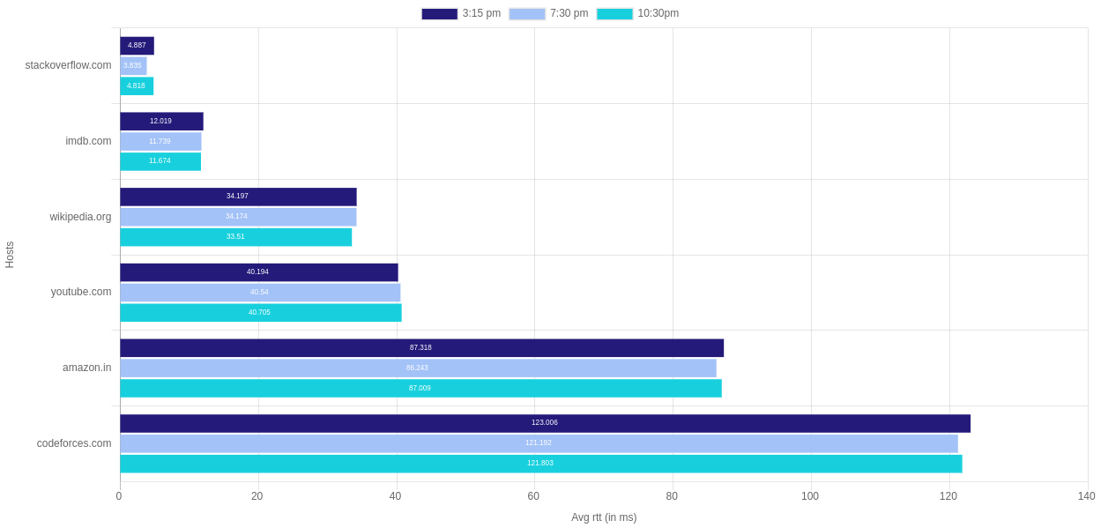Illustration 2 : CORRELATION BTW RTT ,TIME AND DISTANCE

Q3 : PING -n and PING -p :
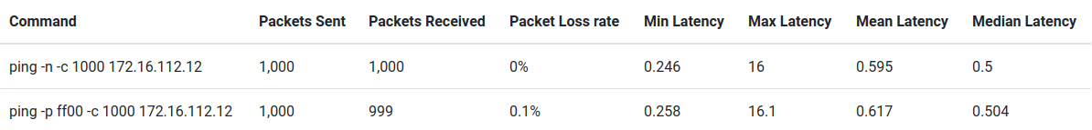
* Both the commands are sending 1000 packets to the same host. Hence, they are very similar, except for two aspects which are as follows :
a) The -n (numeric only) option is expected to be faster, as it displays the raw ip addresses without looking for more human friendly host names (like google.com)
b) The -p ff00 (pattern) option fills the packet with 16 pad bits. This is used for dianosing data-
dependent problems, like synchronisation problem of clocks due to only one transition from 1 to 0 in 1111111100000000 (ff00).
* Due to these apects, the following observations occur in the mapping of <frequency,latency> :
a) The mean latency of -n command < the mean latency of -p command ...(1st aspect)
b) Since synch is data (pattern) dependent, there are higher chances of packet losses, which is observed as shown in the table above. ...(2nd aspect)
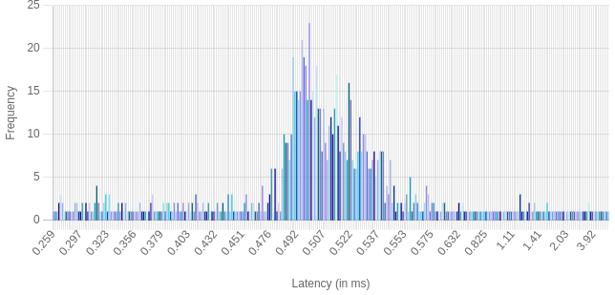Illustration 4 : Normal Distribution for ping -p ff00 -c 1000 172.16.112.12
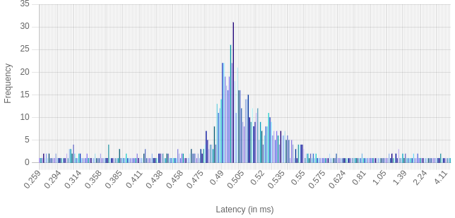Illustration 3 : Normal Distribution for ping -n c 1000 172.16.112.12
Q4 : IFCONFIG and ROUTE command :
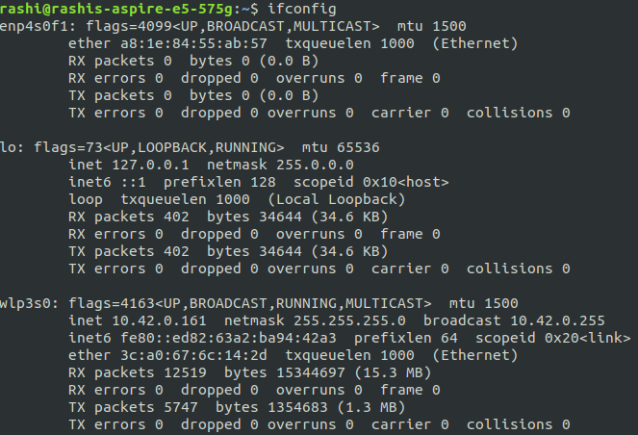
a) I FCONFIG command :
* Inter Face CONFIGuration
* Shows/Configures the list of network
interfaces that are “UP” (enabled)
* Normal Invocation :
ifconfig interface [address [parameters]]
* It is used while booting to set up
interfaces and while debugging and
system tuning.
As observed from the image, it
displays the <interface-name>
followed by its associated flags,
address info and the packet statistics.
(RX : received and TX : transmitted )
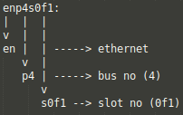
I NTER FACE NAMING :
<type-of-interface, bus no, slot no>

Similarly, wlp3s0 refers to the following :
wl – wireless
p3 – bus no 3
s0 – slot 3

Interface “lo” (as seen in ifconfig result on prev page) however represents loopback, which is the computer’s ref to itself. It is a virtual network interface to communicate with itself for diagnostics, troubleshooting and to connect to servers running on the local machine.
FLAGS : Represent the current status of the interface, for eg :
a) UP : The interface is accessible to the IP layer, hence it has been assigned an address and routing table.
b) BROADCAST : This indicates that the interface supports broadcasting.
c) RUNNING : This indicates that the network driver has been loaded and has initialized the interface.
d) MULTICAST : MULTICAST is like BROADCAST except that instead of automatically including everybody, the
only people who receive packets sent to a multicast address are those programmed to listen to it.
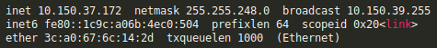
ADDRESS INFO. :
a) inet : Same as IPv4*
b) inet6 : Same as Ipv6**
*IPv4 : 32 bit numeric IP address **IPv6 : 128 bit aplhanumeric IP address
c) netmask : Network Mask for the associated IP address
d) broadcast : 32 bit broadcast address
e) MAC addr (H/w addr) : Address assigned to the LAN card. This addr uniquely defines the device
f) scopeID : This defines the scope of the IP address. For eg, in the img above, Ipv6 addr is local.
g) prefixLen : No of bits in the IP address that are to be used as the subnet mask
h) TXqueueLen : Limits the number of packets in the transmission queue in the interface's device driver
i) MTU : Max number of octets the interface is able to handle in one transaction

b) I FCONFIG instructions :
a) Ifconfig -a : shows all network interfaces including the DOWN ones
b) ifconfig <interface-name> UP/DOWN : enables/disables the mentioned interface
c) ifconfig <interface-name> mtu count : changes MTU value for the mentioned interface
d) ifconfig <interface-name> netmask addr : assigns given netmask addr to the given interface
ifconfig <interface-name> broadcast addr : assigns given broadcast addr to the given interface
ifconfig <interface-name> addr : assigns given addr as IP to the given interface
e) ifconfig <interface-name> promisc : enables promiscuous mode
ifconfig <interface-name> -promisc : disables promiscuous mode
**in promiscuous mode, the driver does not check whether the packet is meant/not meant
for itself and simply accepts all packets

c) ROUTE command :
Normal invocation : route [-f] [-p] [command [destination] [mask subnetmask] [gateway] [metric]]
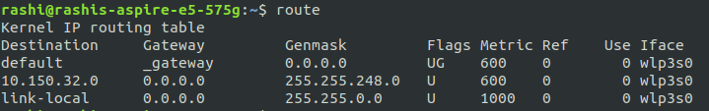
Route is used to show, manip-
ulate kernel’s IP routing table
Primary use : To set up static routes
to specific hosts/networks via interfa
-ce after configuring with ifconfig
IMPORTANT KEYWORDS :
a) Destination : The destination network or destination host.
b) Gateway : The gateway* address or 0.0.0.0, if none set.
c) Genmask : The netmask** for the destination net
d) Metric*** : The metric option assigns an integer cost metric (distance to target in hops)
e) Ref : No of references to the route
f) Use : The count of lookups for a route
g) Iface : Interface to which packets for this route will be sent
h) Flags : U (route is up), H (target is a host), G (use gateway), C (cache entry), ! (reject route),
R (reinstate route for dynamic routing), D (dynamically installed), M (modified)
* Gateways regulate traffic btw two dissimilar networks, while routers regulate traffic btw similar ones
** 255.255.255.255' for a host destination and '0.0.0.0' for the default route.
*** Range – [1-9999], used to calculate the fastest, most reliable, and least expensive routes.
d) ROUTE instructions :
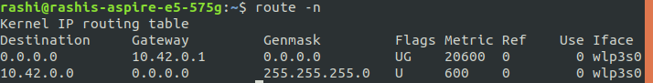
route -n
Show numerical addre-
sses instead of trying to find symbolic host names

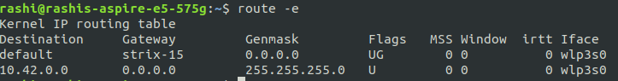
route -e
Use netstat(8) - format for displaying the routing table.
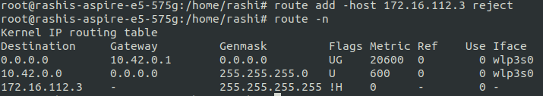
route add -host <addr> reject

Rejecting routing to a particular host
*Notice !H in flags

route add -net 127.0.0.0 netmask 255.0.0.0 metric 1024 dev lo
Adds the normal loopback entry, using netmask 255.0.0.0 and associated with the "lo" device
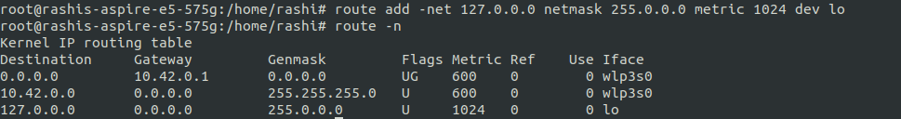

Q5 : NETSTAT command :
a) USE : Netstat is a handy cross-platform (Linux, Windows etc.), which is mainly used for trouble-
shooting and debugging. It is used to :
1) Display incoming and outgoing network connections
2) Display routing tables
3) Display number of network interfaces
4) Display network protocol statistics
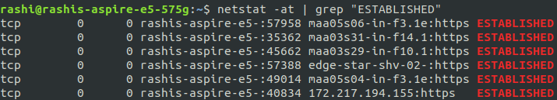
To show all established TCP connections :
netstat -at | grep “ESTABLISHED”

Description of different fields (in order):
Proto : The protocol (tcp, udp, udpl, raw) used by the socket.
Recv-Q : The # of bytes not copied (waiting to be sent) by the user program connected to socket.
Send-Q : The # of bytes not acknowledged (waiting to be read) by the remote host.
Local Address : <Address, port number> of the local end of the socket.
If the --numeric option is not specified,
the socket address --> canonical hostname
the port number i--> corresponding service name.
Foreign Address : <Address, port number> of the remote end of the socket.
State : This field refers to the state of the socket. It is left blank in UDP/UDPLite connections.
Some values are :
– ESTABLISHED (the socket has an established connection),
TIME_WAIT (The socket is waiting after connection is closed by remote machine to handle packets still in the network),
LISTEN (the socket is listening for incoming connections), etc.
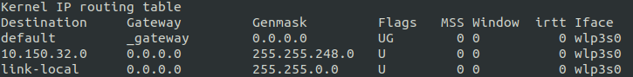
c) netstat -r :
‘MSS’ : Maximum Segment Size(size of largest datagram constructed for transmission),
‘Window’ : default window size(maximum amount of data the system will accept in one burst from a remote host),
‘Irtt’ indicates Initial Round Trip Time for TCP connections over this route.
Please refer Q4 part d for the remaining fields
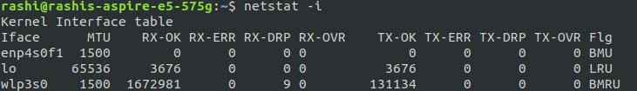
d) netstat -i : My machine has 3 interfaces enp4s0f1, lo,wlp3s0. Please refer Interface naming in Q4
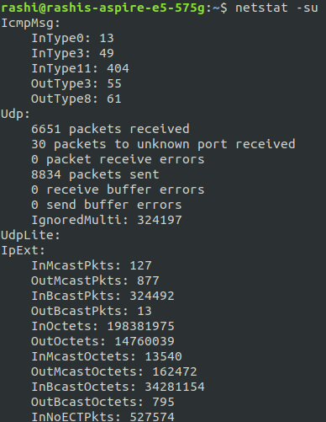
e) netstat -su : To show statistics of UDP connections

f) Loopback interface :

This is the computer’s ref to itself. It is a virtual
network interface to communicate with itself for diagnostics, troubleshooting and to connect to
servers running on the local machine.

The range is 1 – 127.0.0.0/8
Local Host : 127.0.0,1

Q6 : TRACEROUTE command : Prints the route that a packet takes to reach the host.
Useful when you want to know about the route and about all the hops that a packet takes.Seeing the traceroute information can help you determine why your connections to a given server might be poor and can help you identify problems. It also shows you how systems are connected to each other, letting you see how your ISP connects to the Internet as well as how the target system is connected.

a) Hop counts : Below are the tables showing hop counts for each host

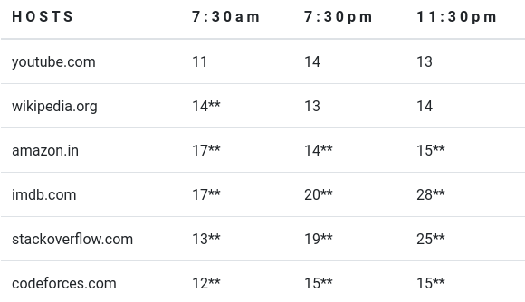
Since only 2 out of 6 hosts from question 2 were
reached using trace command, below is a table with
some extra hosts who were traced by traceroute
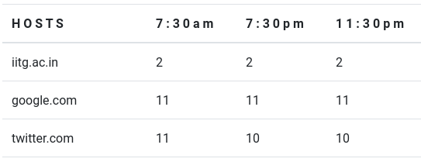

**represents hosts that were not reached in 64 hops

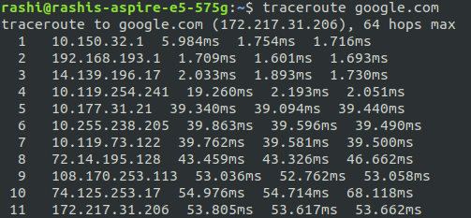
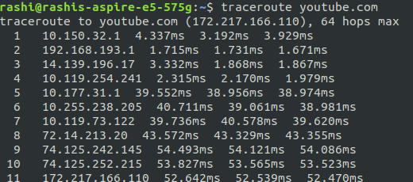
a) Common hops : Just like the images below, the top 7 hops were observed to be common in all the traceroutes, like twitter.com, amazon.in, etc.

Here the first common entry is 10.150.32.1, which is my device. The other common hops occur because the packets pass through the same routers (for instance in the example above both servers lie in USA, hence first the
packets are routed to reach USA, before diverging to their respective location-based gateways.)
b) Route changes based on time of day : Since the internet commonly follows packet switching, the data is sent in packets which are routed by layer 2, layer 3 routers. This routing is affected by the load balancing techniues to reduce the effect of congestion in the link, due to which packets might go through diff paths to reach the same destination if one path is congested.
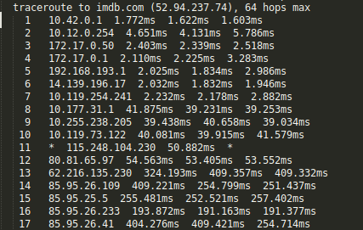
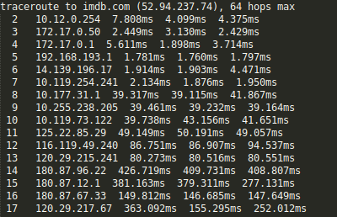

As seen above, the intermediate hops for imdb.com are different for 7:30pm (left) and 11;30pm (right)
c) Traceroute unable to find any route :
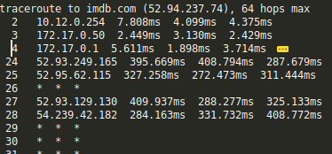
As shown in the image on the left, traceroute may be unable to find a route to some hosts because traceroue follows ICMP protocol which shares data via low priority packets. Due to this, the packets are prone to being dropped by networks in case of heavy congestion. Furthermore, these packets are also prone to being blocked by firewalls. Consecutive rows of * * * (asterisk) symbolize that packets are not acknowledged by the router in the given timelimit.

d) To find route when ping fails : Yes, it is possible to find the route to certain hosts which do not respond to ping. While ping works with simple ICMP, there is another tool known as Tracert which works by targeting the final hop, but limiting the TTL and waiting for a time exceeded message, and then increasing it by one for the next iteration. Therefore, the response it gets is not an ICMP echo reply to the ICMP echo request from the host along the way, but a time exceeded message from that host. Thus, by increasing the TTL based on the last router’s response, the packet is saved from being dropped and can reach the host.

Q7 : ARP command : arp [-v] [-i if] [-H type] -a [hostname]
ARP stands for Address Resolution Protocol. The primary function of this protocol is to resolve the IP address of a system to its mac address. ARP command shows the MAC addresses resolved from the IP address (please note :
this resolution is not done by ARP command, it simply shows the ARP cache containing the resolved pairs)
a) Show complete ARP table : To show complete table, do not write any hostname after arp
arp:the image shows the complete table in default format of ARP
arp -a :the image on the right shows the complete table in BSD style output format
IMPORTANT KEYWORDS :
a) Address : This is the IPv4 address of the dest which has been resolved to MAC address
b) HWType : This represents the type of hardware, which in the image above is “ethernet”
c) HWAddress : This is the MAC address of the dest which has been resolved from the IP address
d) Flags : The flags convey the status of the address, check flag types from Q4 ROUTE FLAGS
f) Interface : This is the name of the interface, check the convention from Q4 INTERFACE NAMING
b) Modifying ARP table : To modify the ARP table, the user must have super-user privileges
To add or change an existing entry, follow arp -s <IP_address> <H/W Address> ..1)
To delete an existing entry, follow arp -d <IP_address> <H/W Address>
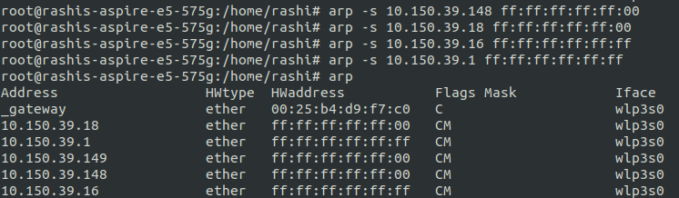

arp -s <IP> <H/W Address>

The image on the left shows the four hosts that were added by command 1)

c) ARP table timeout : The exact time when an entry would be removed can not be predicted as it depends on a number of parameter :
gc_stale time : If an entry hasn’t been used for these many sec, then it is marked stale (eligible for removal during garbage collection)
gc_interval : This is the time after which the garbage collector runs periodically
It is important to note that permanent entries are not deleted, but normal entries after gc_stale time are make stale (eligible for deletion) and then wait for the next gc_interval to arrive to be deleted in garbage collection process.

ALGO TO PREDICT TIMEOUT :
A method similar to poling can be used. For a newly added dummy entry, monitor the time after fixed intervals to see when the entry is deleted A trial and error method to discover the timeout value is to add a temporary entry in the ARP table and keep on checking its presence after fixed intervals of time (say 5 seconds). Smaller the poling time, better would be the approximation.
Alternatively, one can use binary search for finding the cache time, for e.g. – Add a temporary entry in ARP and check after 5000ms. If then entry has been deleted, then add the entry again and check after 2500ms.
The more no of iterations, the better will be the approximation.
d) Two IP address mapped to same Ethernet Addr : The scenario where two IP’s can map to same Ethernet Address is when a router or a gateway connects two or more subnet ranges. When communicating with machines on the same subnet range, MAC address is used for directing the packages. In the
ARP Table, the IP’s of the devices which are connected in the other subnet range have the ethernet address/MAC address as that of the Router or Gateway which connects the two subnet ranges. ARP table is referred to convert these IP addresses to the MAC address and packets are sent to it(router/gateway). The router then uses it’s routing table and sends the packet further to the correct device.

Q7 : ARP command : nmap -n -sP <subnet>/22 Subnet used : 10.16.0.254
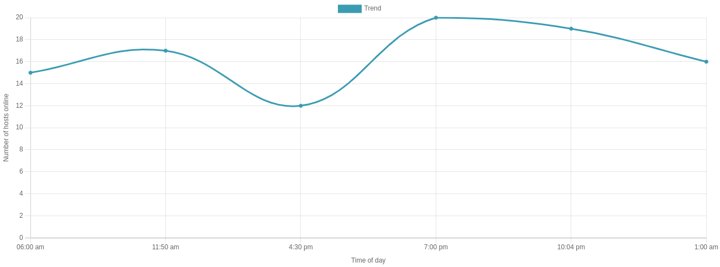
OBSERVATION : As observed from the image above, the number of hosts are very low during the morning and class-hours. The number of hosts online increases from 6:00 am till 11:50 am. Then there is a sharp decrease and reaches a minimum of 12 at 4:30pm (Class hours). After class hours there is an increase and reaches a maximum at around 7:00pm and then gradually decreases again. These observations clearly state when the computers are switched ON or OFF in my LAN.

